FULL NAME : BABALWA SIGAMLA

**OVATION E-COMMERCE WEB APPLICATION DOCUMENTATION**

**Problem statement – project overview**

The main and the basic issue is that we are having a youth that have already surrender their selves in alcohol which that sometimes put their lives at risk the main reason of this project is not to promote the sale of alcohol but to protect our brothers and sisters from being killed under the influence of alcohol, the more people who are present at one place the higher the risk of getting hurt. Developing this web application more especially for one of the places in rural areas the lesser the risk of people loosing their lives. people can be able to do the order while sitting at home and it will be delivered straight to your address provided , and I believe that can improve lives and save lives.

**Plan SDLC**

SDLC is a structured process that enables the production of high quality ,low cost software , in the shortest possible production time.

We have 7 stages in SDLC which includes : 1. Planning Stage

2.Analysis and defining requirements

3. Designing

4.Implementation and Coding

5.Testing

6.Deployment

7.Maintenance

Planning

I will be doing a web application for the well known tarven in my area which is called Top15 Tarven, which will make lives easier more especially in our generation where by alcohol is the only solution to our problems . My goal for doing this project is to limit the lives lost under the influence of alcohol. People tend to fight a lot when they are drunk and end up hurting each other and many cases and deaths reported on hospitals are due to this substance abuse. I am planning to be done with this project in a month time and I should be be reporting to my trainer all the challenges I am facing also showing what have I done so far. My main targets through all of this is Youth because they are the only people who are more at risk when they are drunk, they are killed, kidnapped, rapped . This Application will be selling alcohol all categories they may need and if you believe there is something left out you are allowed as a customer to put your view and suggest what should be added and I will be making sure that all that is done.

Analysis and defining requirements

This is a big Project that comes with big responsibilities and commitment so I was not going to be able to do this all by myself, I had to go to the owner of the place and try to take his view and opinion on what he prefers the app should look like . I also had to go around asking asking the users what they think about the application idea what are their needs by doing this I was able to have an idea of what exactly is needed to be done. There are many competitors in this business which make me very confident to be doing this because that will mean the business will be improving and unique to others .My functionalities for the project will be:

* Login button that will allow you to enter a home page if you are already a user also tell if you are not so that you will be able to register a new account and be added into the database.
* A Home page that will be able to display comments and stories from our customers
* A button that will enable a user to add things to cart also remove thing to cart.
* A search box that will allow you to search an item straight to our database and see if it is available or not
* A text box that will enable you to put your address for delivery and go straight to the map to get your address if your place is in one of the places that are able to receive a delivery.

And the Technology I will use is : Front End(HTML,CSS,JAVASCRIPT,C#,ERD EDITOR AND ANGULAR)

Back End (MY SQL SERVER FOR DATABASE)

Designing

This Template simple shows a login page where we have our Tittle as a Login , 2 Text boxes that will contain your username and password also they will be validated just to make sure that there is an input , And we have our Button Login that will take you to a home page if your details were correct also I have a link for Sign up in my page that will take you to another page where you will be able to register your account.

This will be my Sign up page where I have a Tittle for sign up , 4 Textboxes 2 will contain the actual values you will be using to Login and another 2 its for confirmation that these values you have entered are what you actually wanted and we have our button for sign up that will take you to a login page if your account was actually Verified.

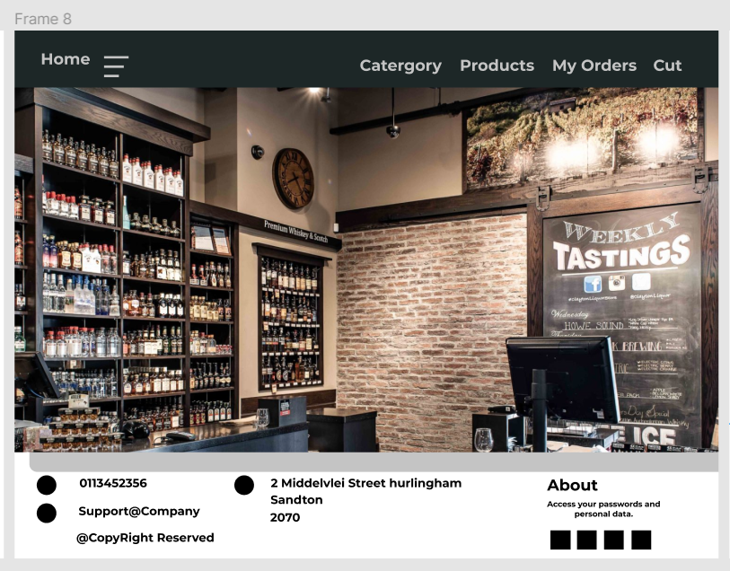

This will be my Home page where there will be my Nav bar that contain Category , Products, My Orders and Cart also on My footer I will be having address of the shop contact details also History about the shop

1. Category- This will have all the categories of what I will be selling which will be Wines, Ciders, Beers and Spirits.
2. Products- this will be containing all my items including prices that is where you will be able to add your desired items to cart using your button Add to Cart that you will find on that page.
3. My orders- This will keep all the records of all the previous orders made .
4. Cart- This page will be the page where you will be able to see all your items you have selected delete some if you want to also add some if you want to also there will be a Button below Checkout Button that will take you to payment and delivery page.  
  
  
And this will be my Checkout page where you will enter your name and surname also email ,address ,city and postal code this is all necessary for delivery purposes, And we also have our payment side that will actually allow you to enter you card details for further processing and on the other side we have a cart page that will show your products also the amount you have to pay then we also have our button below for further checkout then it will take you to my final template where if you are successful .it will just be “Thank you for shopping with us, hope to see you soon”

Implementing and Coding

My code will be strictly on the technologies mentioned about and I will try to keep it as simple as possible also make sure that it is on the correct format that will be able to be re usable for future use .Angular will be able to make my pages more actively and html will be for my visible layout, css will be for my styling and java script is for functionality . and also sql server for my database and combine all my work afterwards for testing purposes.

Testing

Application can be seem to be okay until you test it that is where you will realize what you have been doing was correct or incorrect. I will have to give my application to my friends to test for me try and see if all the things are working as planned also give me their feedback according to their experience on using this Application.

Deployment

I am planning to deploy this application on the last week before month end to make sure that all the people are satisfied and it is working perfectly fine .Also I am planning to first give it to my family and friends to try it before giving it to other people I believe by so doing people will be able to trust me with their work because of what the will see .

Maintenance

You do not only have to develop an application also you have to maintain it for lifetime , you should be doing updates and all the required stuff also adding some items , as I was planning before that the opinion and the suggestion from users is highly recommended I am planning to add if people still believe that there is somewhere this application is lacking from. I am here to make sure the all the needs of the customer met also try to show that how far technology can go to make your life simple

OBJECT-ORIENTATED PROGRAMING

OOP is a paradigm in which programs are written and structured around objects rather than functions or logic. Here objects are defined as data fields that have unique attributes behavior

FOUR MAIN PRINCIPLES OF OOP

1. Encapsulation – is the binding of data into a single unit, it is accomplished when each object inside the class keeps its state private.
2. Abstraction – Is an extension of encapsulation , it provides only necessary information to the outside world while hiding the internal details of implementation.
3. Inheritance – Often , objects are similar in functionality , sharing part of the logic but differing in the rest.
4. Polymorphism – Polymorphism is the ability to take more than one form

ADVANTAGES OF OOP

1. A real world idea can be demonstrated as everything in OOP is treated as an object
2. As we use the concept of Encapsulation , programs are easier to test and maintain
3. Reusability can be achieved by using classes that have been already written.
4. OOP provide greater security due to data abstraction .

USE CASE MODELLING

ENTITY RELATIONSHIP DIAGRAM

CLASS DIAGRAM

SEQUENCE DIAGRAM

ARCHITECTURE DIAGRAM

DATA FLOW DIAGRAM

UI DIAGRAM

ACTIVITY DIAGRAM

